PIZZA SALES SQL QUERIES

KPIs

1. TOTAL REVENUE

SELECT SUM(total_price) AS Total_Revenue FROM pizza_sales

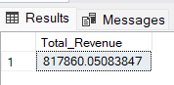

2. SELECT SUM(total_price) / COUNT(DISTINCT order_id) AS Avg_Order_Value FROM pizza_sales

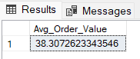

3. TOTAL PIZZAS SOLD

SELECT SUM(quantity) AS Total_Pizza_Sold FROM pizza_sales

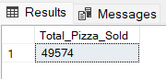

4. TOTAL ORDERS

SELECT COUNT(DISTINCT order_id) AS Total_Orders FROM pizza_sales

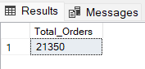

5. AVERAGE PIZZAS PER ORDER

SELECT CAST(CAST(SUM(quantity) AS DECIMAL(10,2)) /

CAST(COUNT(DISTINCT order_id) AS DECIMAL(10,2)) AS DECIMAL(10,2)) AS Avg_pizzas_per_order FROM pizza_sales

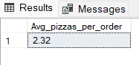

CHARTS REQUIREMENTS

1. TOTAL ORDERS BY DAY OF THE WEEK

SELECT DATENAME(DW, order_date) AS order_day, COUNT(DISTINCT order_id) AS total_orders

FROM pizza_sales

GROUP BY DATENAME(DW, order_date)

ORDER BY total_orders DESC

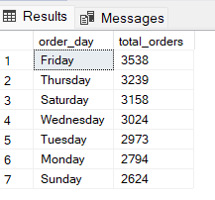

2. TOTAL ORDERS BY MONTH

SELECT DATENAME(MONTH, order_date) AS Month_Name, COUNT(DISTINCT order_id) AS total_orders

FROM pizza_sales

GROUP BY DATENAME(MONTH, order_date)

ORDER BY total_orders DESC

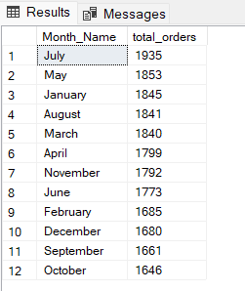

3. PERCENTAGE OF TOTAL SALES BY PIZZA CATEGORY

SELECT pizza_category, CAST(SUM(total_price) AS DECIMAL(10,2)) AS Total_sales, CAST(SUM(total_price) * 100 /

(SELECT SUM(total_price) FROM pizza_sales) AS DECIMAL(10,2)) AS PCT

FROM pizza_sales

GROUP BY pizza_category

ORDER BY PCT DESC

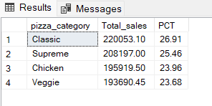

4. PERCENTAGE OF TOTAL SALES BY PIZZA SIZE

SELECT pizza_size, CAST(SUM(total_price) AS DECIMAL(10,2)) AS Total_sales, CAST(SUM(total_price) * 100 /

(SELECT SUM(total_price) FROM pizza_sales) AS DECIMAL(10,2)) AS PCT

FROM pizza_sales

GROUP BY pizza_size

ORDER BY PCT DESC

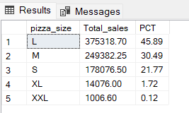

5. TOP 5 PIZZAS BY REVENUE

SELECT TOP 5 pizza_name, CAST(SUM(total_price) AS DECIMAL(10,2)) AS Total_revenue

FROM pizza_sales

GROUP BY pizza_name

ORDER BY Total_revenue DESC

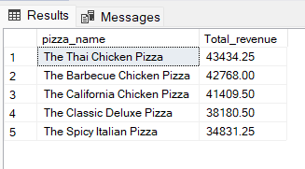

6. WORST 5 PIZZA BY REVENUE

SELECT TOP 5 pizza_name, CAST(SUM(total_price) AS DECIMAL(10,2)) AS Total_revenue

FROM pizza_sales

GROUP BY pizza_name

ORDER BY Total_revenue ASC

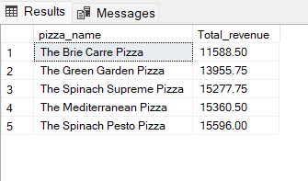

7. TOP 5 PIZZAS BY QUANTITY

SELECT TOP 5 pizza_name, SUM(quantity) AS Total_Quantity

FROM pizza_sales

GROUP BY pizza_name

ORDER BY Total_Quantity DESC

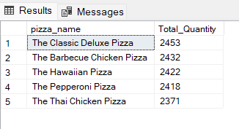

8. BOTTOM 5 PIZZAS BY QUANTITY

SELECT TOP 5 pizza_name, SUM(quantity) AS Total_Quantity

FROM pizza_sales

GROUP BY pizza_name

ORDER BY Total_Quantity ASC

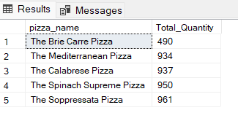

9. TOP 5 PIZZAS BY ORDERS

SELECT TOP 5 pizza_name, COUNT(DISTINCT order_id) AS Total_Orders

FROM pizza_sales

GROUP BY pizza_name

ORDER BY Total_Orders DESC

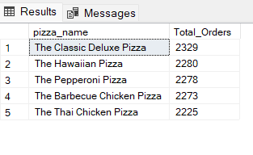

10. LEAST 5 PIZZAS BY ORDERS

SELECT TOP 5 pizza_name, COUNT(DISTINCT order_id) AS Total_Orders

FROM pizza_sales

GROUP BY pizza_name

ORDER BY Total_Orders ASC

